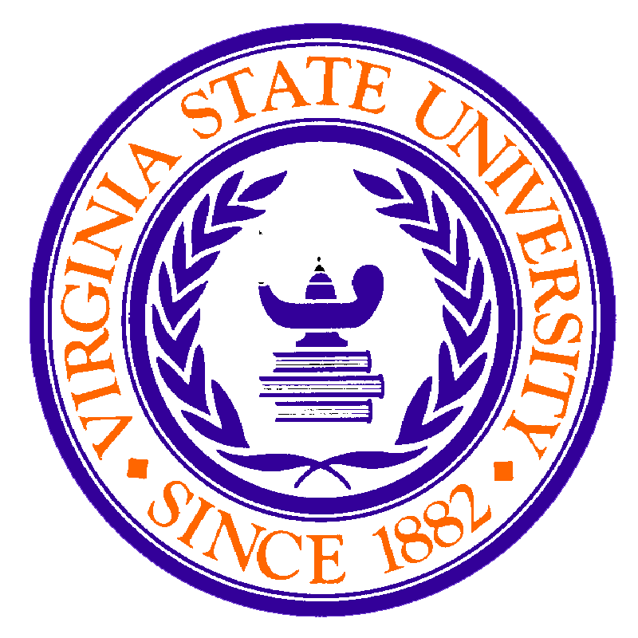Virginia State University
Petersburg, Virginia 23806
TEL (804) 524-6709 ▪ FAX (804) 524-6844

HONORS COLLEGE

November 7, 2024

To whom it may concern,

It is my pleasure to write this letter of recommendation on behalf of Raven Mott. I am Professor Arnold Westbrook, and I have had the pleasure of working alongside Raven since his enrollment as a freshman at VSU. I would say that I have seen growth in him, however his work ethic and tenacity remains at an elite level since the incarnation of our relationship. I have the pleasure of being his advisor for the #crownHIM male initiative housed in the Honors College of Virginia State University.

Upon initially meeting Mr. Mott, I was quickly impressed with his ability to open up and speak confidently in a room full of strangers. This is an awesome trait to have as a young man from the Carribean that may have different perspectives and wisdom to share. Raven has an aura about him that exudes confidence and maturity. He has a great personality and attempts to express his thoughts to gain a better understanding of the VSU community and ways to be a leader. He has participated in community service activities and is an organized student who enjoys putting out a quality product.
In all that he does, Raven is a leader that works well in groups and is a reliable individual. He is the type of student I believe would make a great Resident Assistant working for VSU Housing. I believe if afforded the opportunity, Mr. Mott will succeed in this endeavor. If you have any questions, fell free to contact me at (804) 524-5172.

"I Am HIM"
Arnold Westbrook
Honors College
Virginia State University
Awestbrook@vsu.edu
(804) 524-5172



